




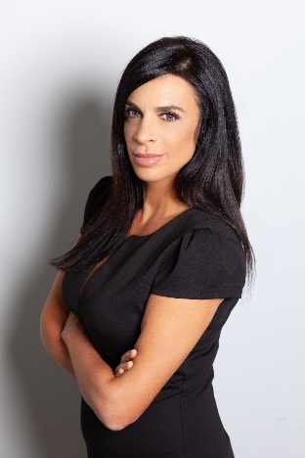



WTHR-TV Channel 13 | Indianapolis, IN
Indiana Statehouse & General Assignment Reporter | 2007 – Present
Report on the Indiana General Assembly, while also covering other stories dealing with politics, public policy, and Indiana residents. Report breaking, enterprise, general and feature news stories that frequently gain national exposure, under extreme deadlines for WTHR-TV Channel 13’s daily television newscasts, website, and social media accounts.
- Develop, research, and pitch daily and enterprise stories from community contacts and sources, reaching thousands of television and social media viewers daily
- Represent WTHR-TV Channel 13 at speaking engagements for a variety of causes, including participating on panels to discuss working in media and covering politics
- Featured on NBC Dateline “A Walk In the Woods” The Delphi Murders, Investigation Discovery’s
The Shift and A&E’s The First 48 for coverage of crime in Indianapolis & Cincinnatti.
HIGHLIGHTED WORK
Giving Birth in Shackles: An incarcerated Indiana mother recounts what it was like to give birth in chains. Kristina Covitz shared her story with Indiana lawmakers in hopes of changing a state law, which allowed the Department of Corrections to shackle incarcerated pregnant women, even during labor.
https://www.youtube.com/watch?v=DMTZ-jDd-6o

A Mother’s Unanswered Questions:
https://www.wthr.com/article/news/local/mother-says-negligence-led-to-daughters-death-at-former-marion-county-community-corrections-work-release-facility-craine-house/531-bf04d211-7389-4525-8cc2-d97223ec74e0

Composing a Masterpiece Life:
https://www.youtube.com/watch?v=Sl8ZqDPyw28

Women Journalists at Ground Zero:
Featured for coverage of the September 11, 2001 terrorist attacks
WLWT-TV Channel 5 News Cincinnati, OH
General Assignment Reporter 2004 – 2007
WGAL-TV Channel 8 News Lancaster, PA
Fill-In Anchor/General Assignment Reporter 2002 – 2004
WTAJ-TV Channel 10 News Altoona, PA
Fill-In Anchor/General Assignment Reporter 1999 – 2002
WENY-TV Channel 36 News Altoona, PA
Morning Anchor | Health Reporter 1998 – 1999
The Washington Bureau Washington, DC
Field Producer 1996 – 1998

PROFESSIONAL EXPERIENCE
TV | Web | Social Media | Public Speaking | Podcasts
SOCIAL MEDIA
Emily Longnecker TV News
/EmilyLongneckerWTHR
/in/emily-longnecker
/emilywthr
www.emilylongnecker.com/
8 Time Emmy Award Winner
27 Time Emmy Award Nominee
4 Time Indiana Broadcasters Association Spectrum Award Winner
6 Time Indiana Society of Professional Journalists Award Winner
2024 Radio One Inspire Her Honoree
2017 2nd Place Indiana AP Award Winner
2017 American Legion 4th Estate Award Winner

ACHIEVEMENTS
MASTER OF ARTS DEGREE
Public Affairs & Broadcast Journalism
American University
BACHELOR OF ARTS DEGREE
Major: English | Minor: French
Allegheny College
Conversational in French
ENPS | Edius Workgroup 9
Microsoft | Google Suite

EDUCATION | SKILLS
EMILY
LONGNECKER
Journalist | Public Speaker | Storyteller
emily.longnecker7337@gmail.com
(317) 697.9189
Indianapolis, IN

